Design Artifacts and System Modeling



Universidad Nacional de Colombia - Bogotá
Faculty of Engineering
Department of Systems and Industrial Engineering
Course: Ingeniería de Software 2
Teaching: Liliana Marcela Olarte Mesa

Workshop No. 2 — Design Artifacts and System Modeling
Group: Lolas VIP

Students:
Federico Hernandez Montano
Juan David Montenegro Lopez
Felipe Rojas Marin
Juan David Serrano Ruiz
Diego Esteban Ospina Ladino

Proyect

Name
- CACVi-UN

Description
- An online reporting center that allows members of the National University of Colombia's Bogotá campus community to view and report incidents of violence within the university and its surrounding areas

Objective
- CACVi-UN aims to improve security on campus and in the surrounding area by providing users with an interactive map where the university community can report incidents of violence and view recent incidents.
We aspire to be the foundation of a reporting center that not only disseminates information but also serves as a connection between victims and support professionals of all kinds; and a source of data for studies aimed at improving campus security.

CRC Cards

Location
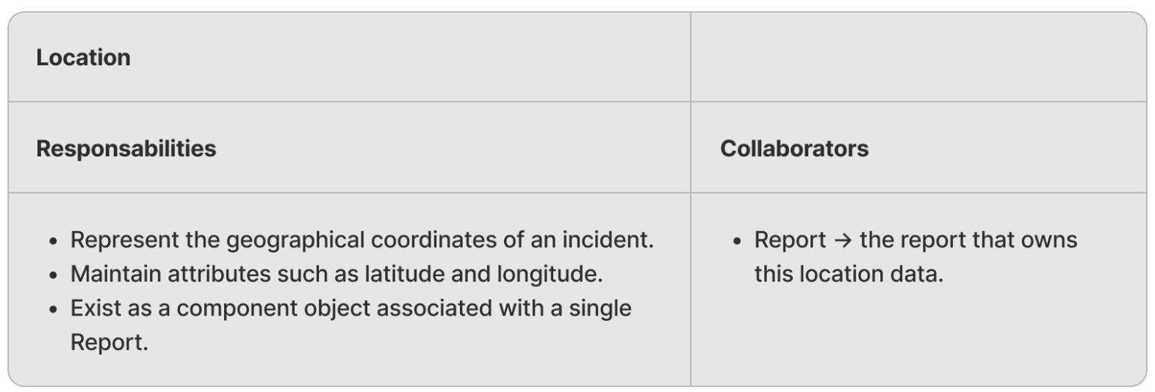

Report
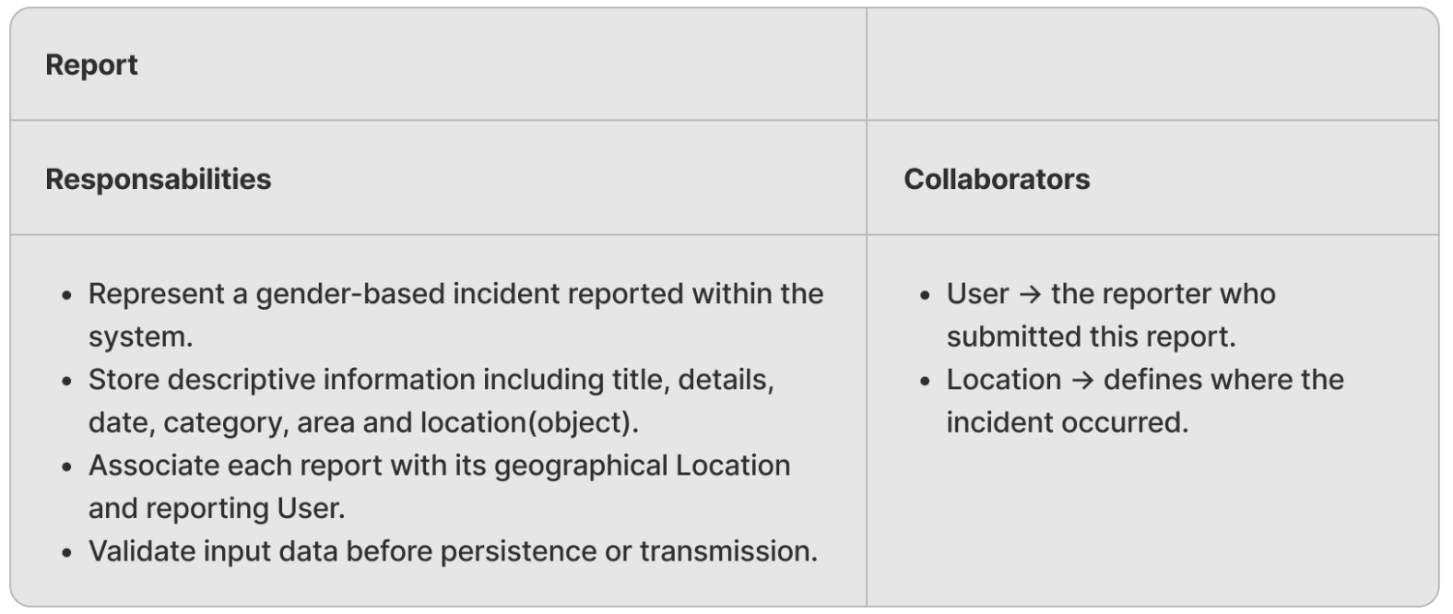

Report History
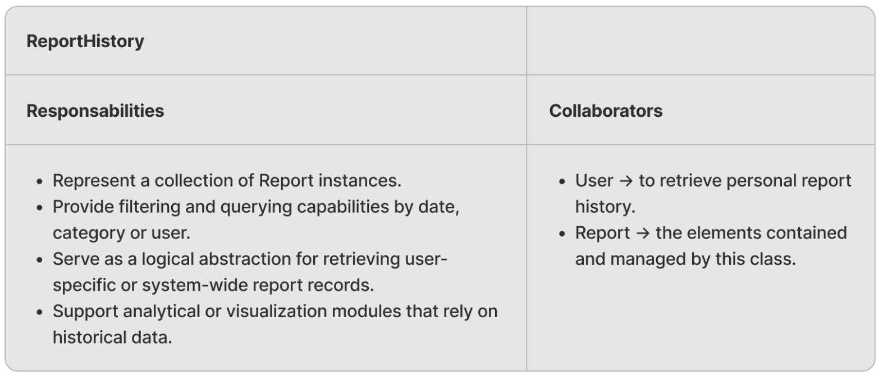

Sessions
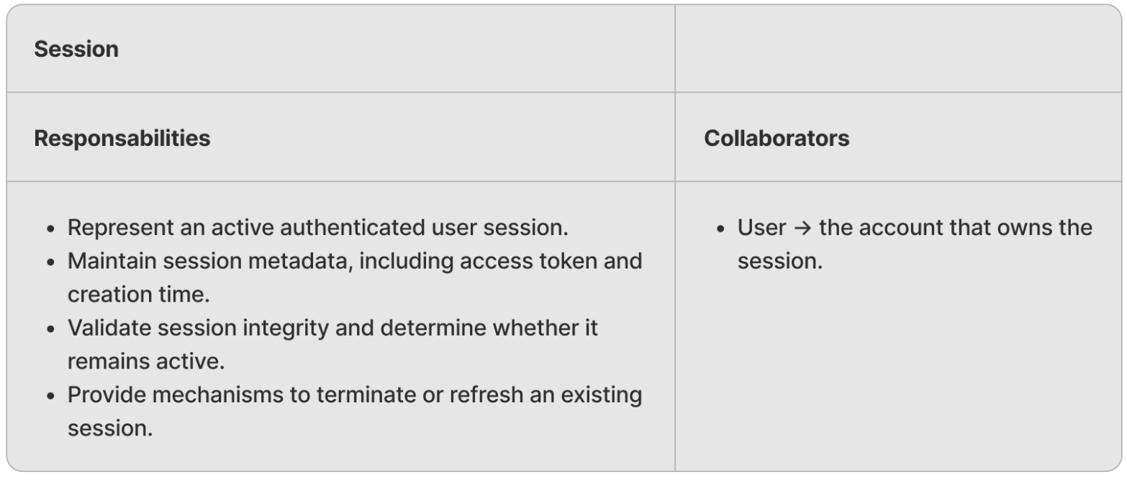

User
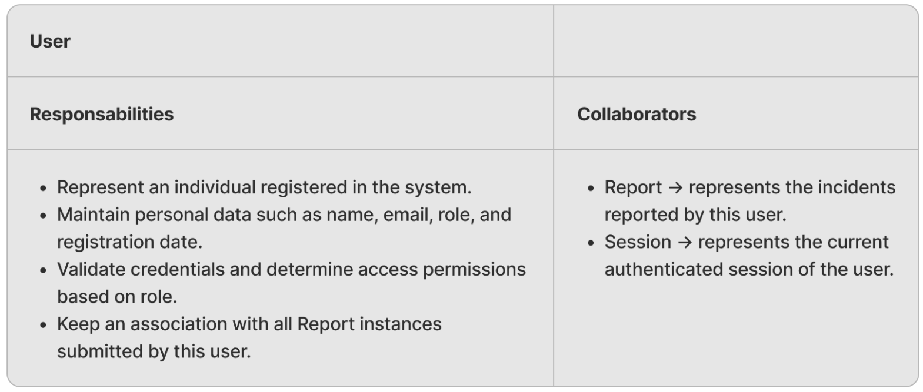

Mockups

Login

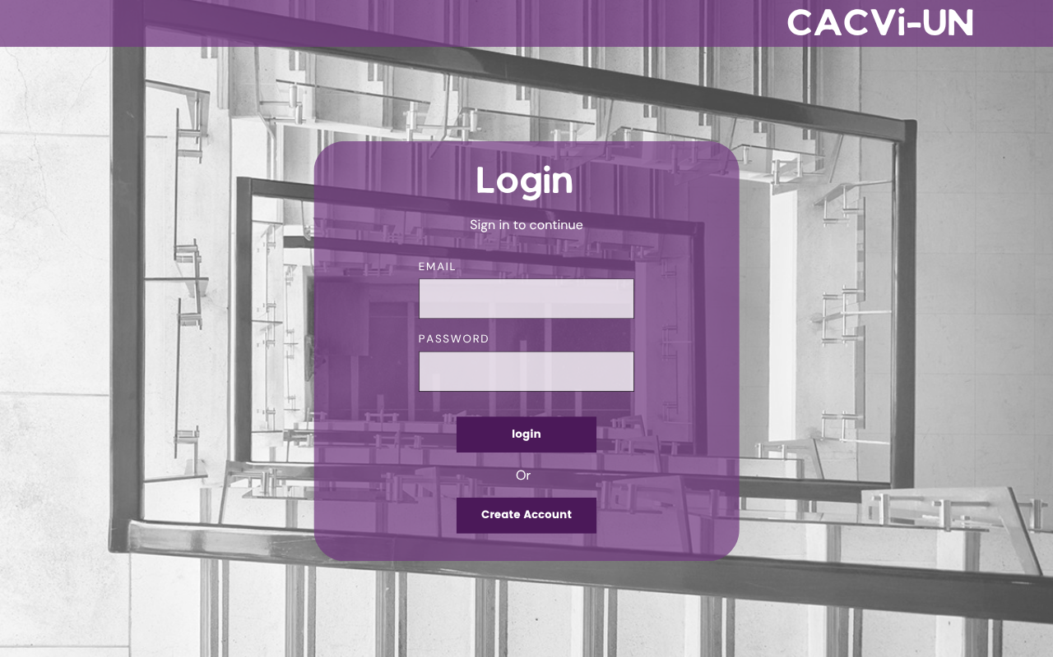

Create account

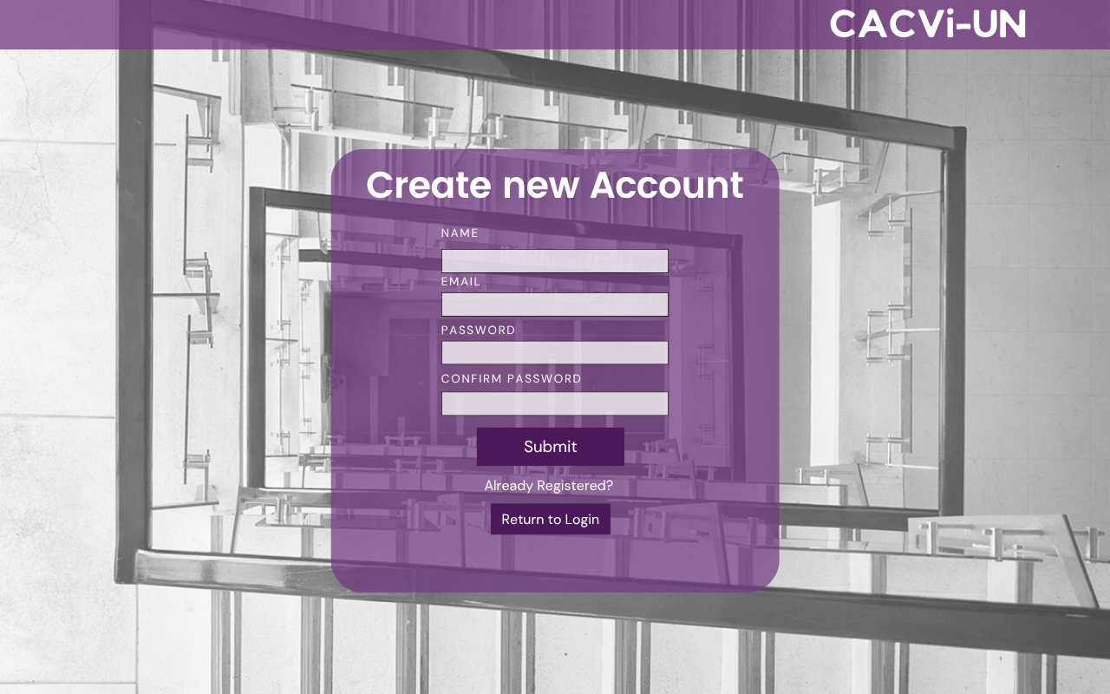

Make report

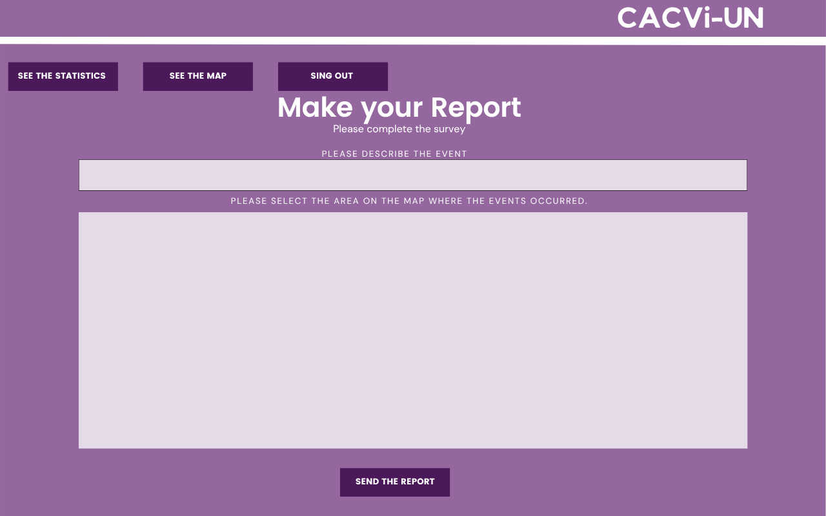

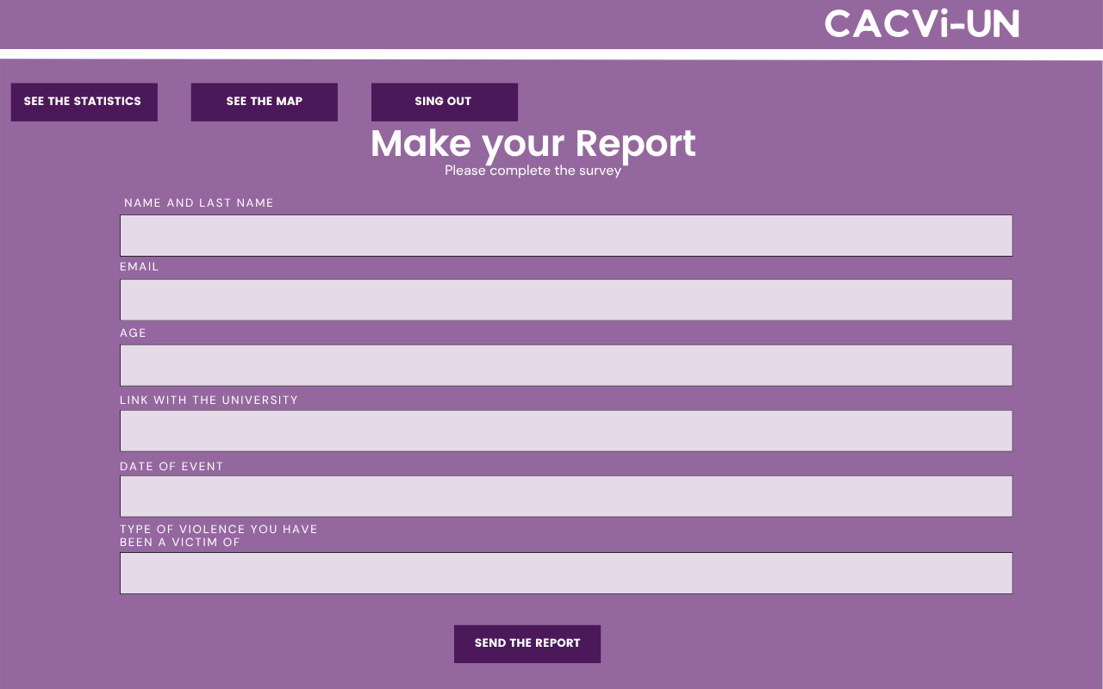

Map

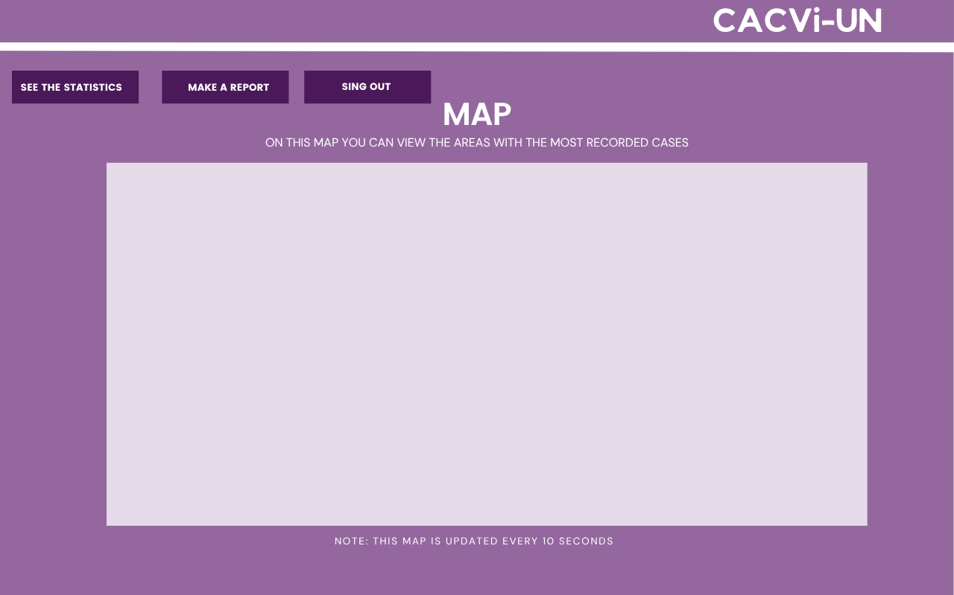

Business Model Processes
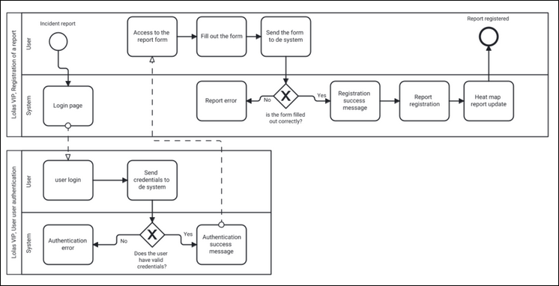
Process: Registration and management of gender-based incident reports.
Represent the complete flow by which a user:
- Accesses the system,
- Creates a new incident report,
- And the system processes, stores, and displays it in the overview or map view.

This is the core business process, as it reflects the application's mission: to record and analyze gender-based incidents to generate information and action.

Architecture Diagram
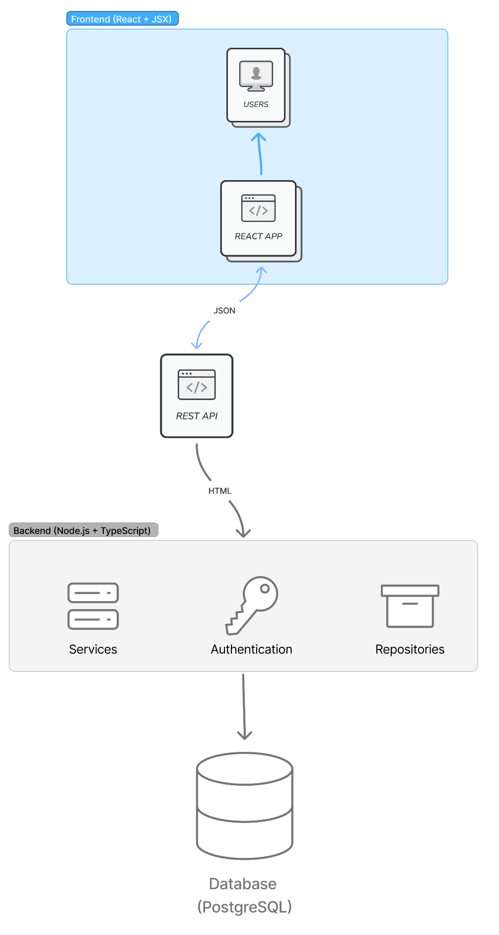
The architecture diagram shows how the files, modules, APIs, and other components that make up the project structure will be defined. It illustrates the communication and general flow of a user and the data they provide to the application.

Class Diagram
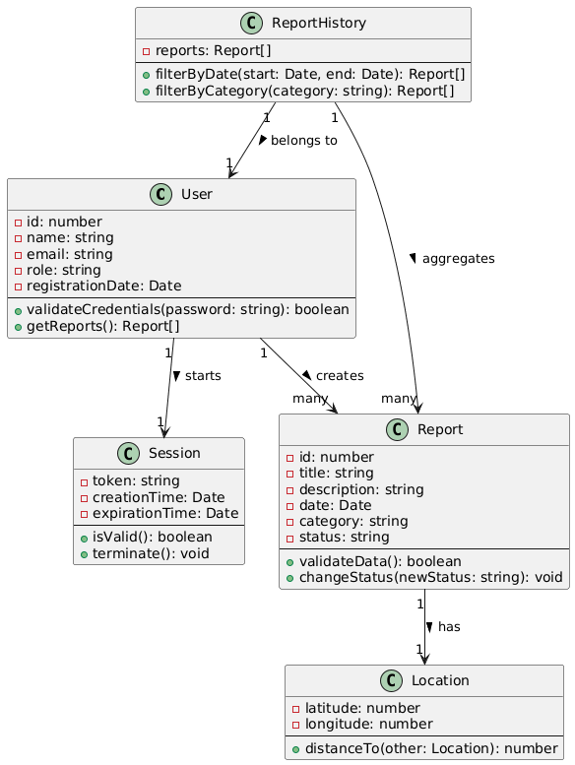
This diagram, created using UML notation, describes in detail the classes that will be instantiated as objects in the back-end of the application project. They will function as templates, maintaining consistent terminology across all modules and allowing for all desired operations.
Furthermore, the cardinality and therefore the relationships between these classes are shown, relationships that define the business rules that will govern the web application.

Relational Database Model
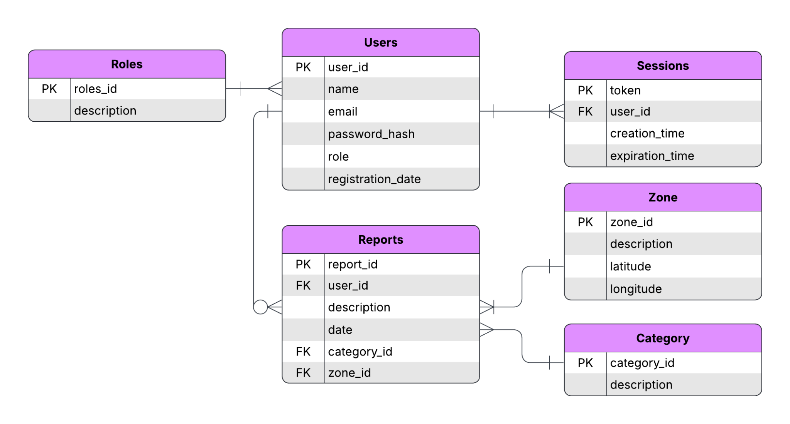
All these files are attached in the project’s repository: https://github.com/juserranor/VIPIngeSoftII.git

